Overview of typical Linux server services, grouped the way sysadmins, DevOps engineers, and lecturers usually explain them.

Typical Minimal vs Enterprise Linux Server
Minimal Server
- SSH
- Firewall
- Logging
- NTP
- One application service
Enterprise Server
- LDAP / Kerberos
- Monitoring + SIEM
- Backup systems
- Load balancers
- High availability (HA)

1️⃣ Core System & Access Services (Foundation)
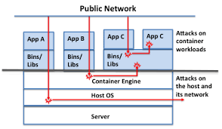
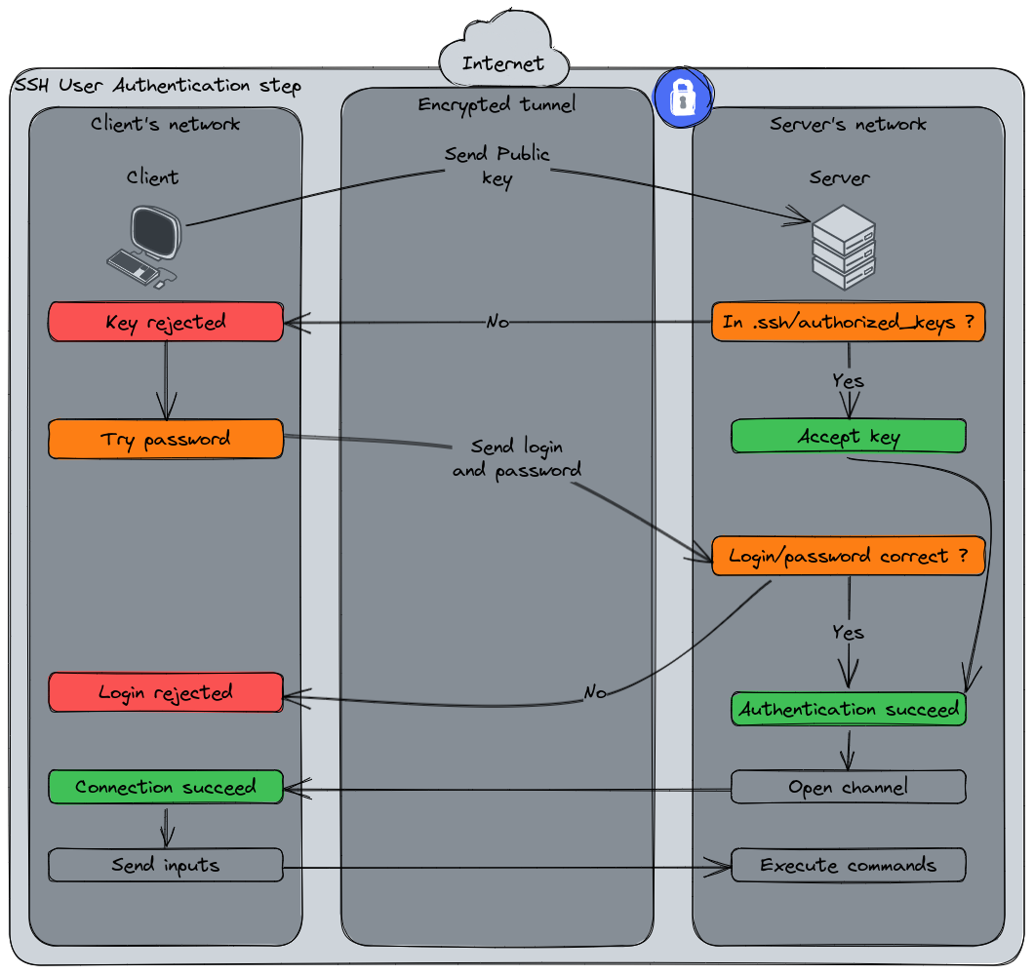
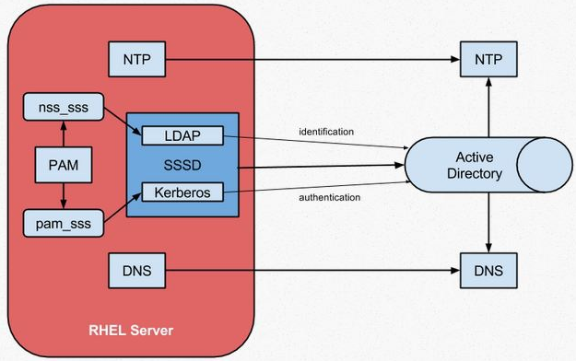
These are essential on almost every Linux server.
Service | Purpose
SSH (sshd) | Secure remote login & administration
Systemd / init | Service manager (starts & supervises all services)
cron / atd | Scheduled & delayed jobs
sudo | Privileged command execution
rsyslog / journald | System & service logging
NTP / chrony | Time synchronization
fail2ban | Blocks brute-force login attempts
📌 Without these, the server is basically unusable or insecure.

2️⃣ Networking & Name Resolution Services
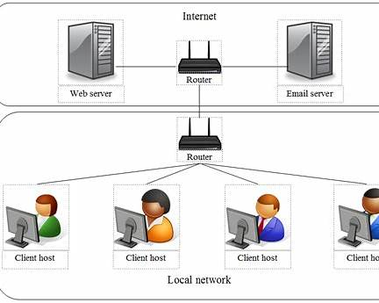
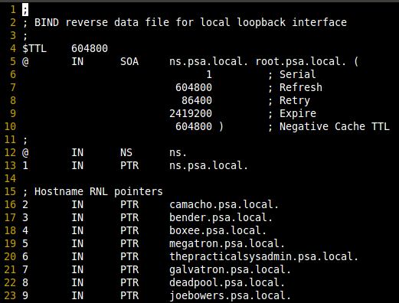
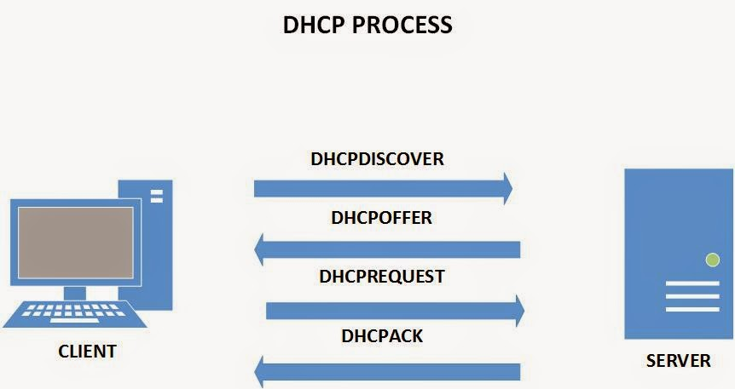
These allow the server to communicate properly on a network.
Service | Purpose
NetworkManager / systemd-networkd | Network configuration
DNS client (systemd-resolved) | Name resolution
DNS server (BIND / dnsmasq) | Hostname ↔ IP resolution
DHCP server | Automatic IP assignment
Firewall (iptables / nftables / firewalld) | Traffic control
Proxy (Squid) | Traffic filtering & caching

3️⃣ Web & Application Services (Most Common)

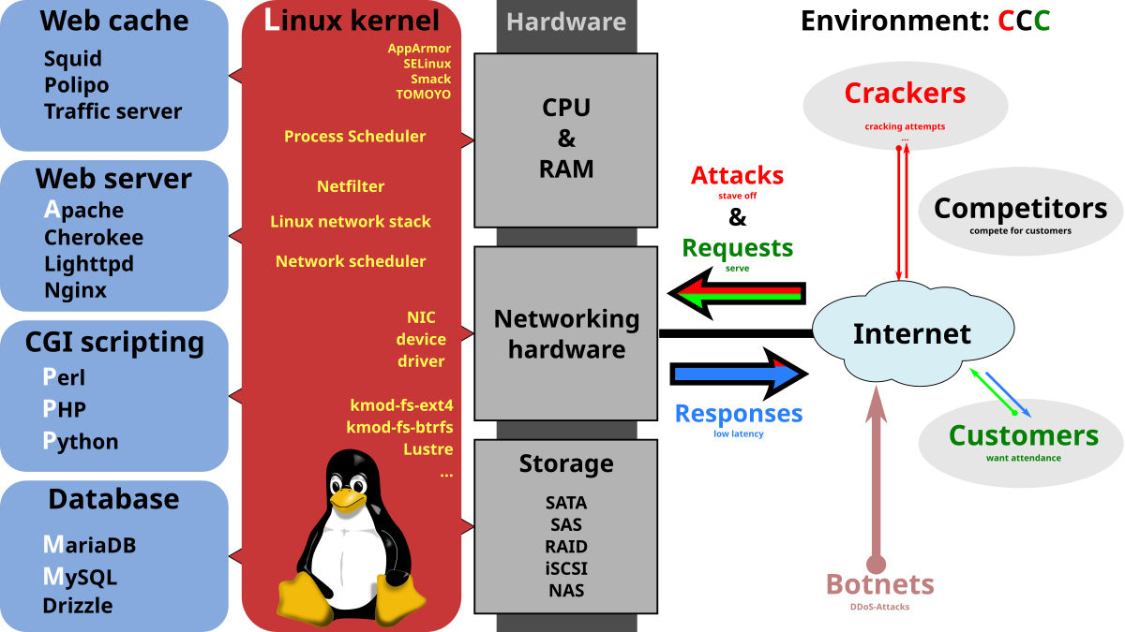
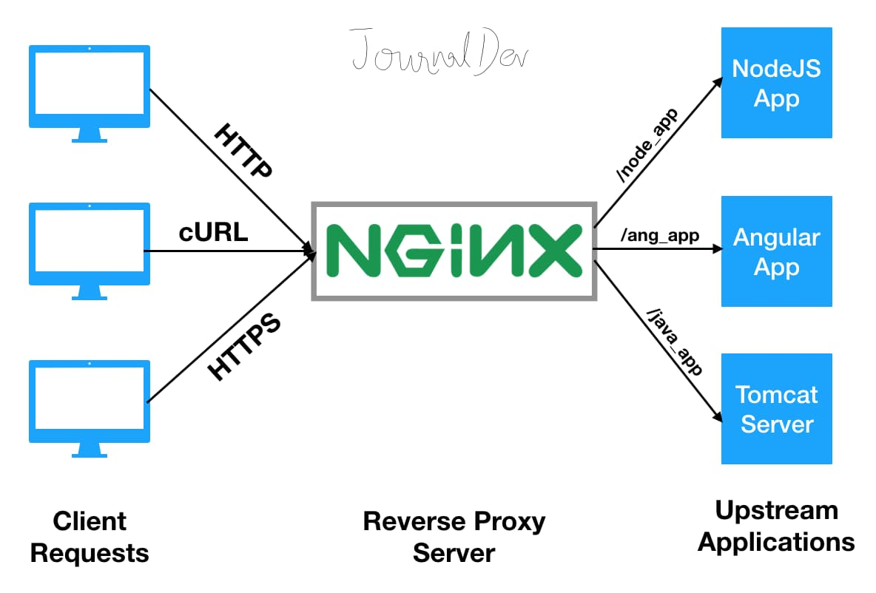
Used for websites, APIs, portals, dashboards.
Service | Purpose
Apache HTTP Server | Traditional web server
Nginx | High-performance web & reverse proxy
PHP-FPM | PHP application engine
Tomcat / Jetty | Java web apps
Node.js | JavaScript backend apps
Gunicorn / uWSGI | Python app servers
📌 Common stacks:
- LAMP: Linux + Apache + MySQL + PHP
- LEMP: Linux + Nginx + MySQL + PHP
- Modern: Nginx + Node/Python + PostgreSQL

4️⃣ Database & Data Services
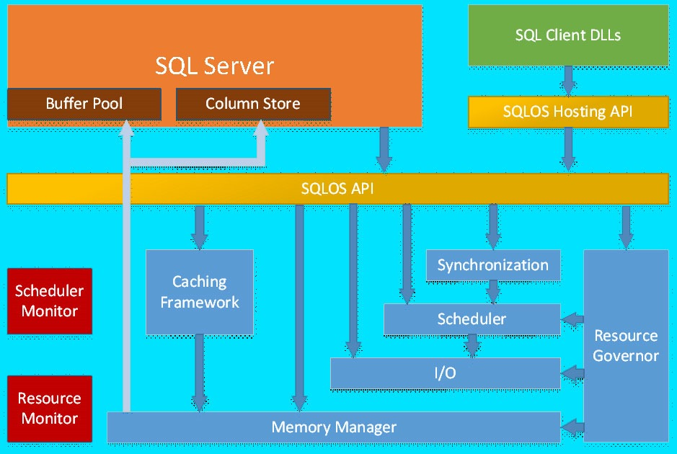
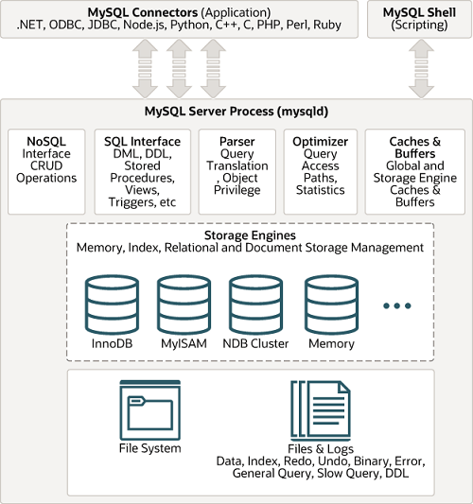
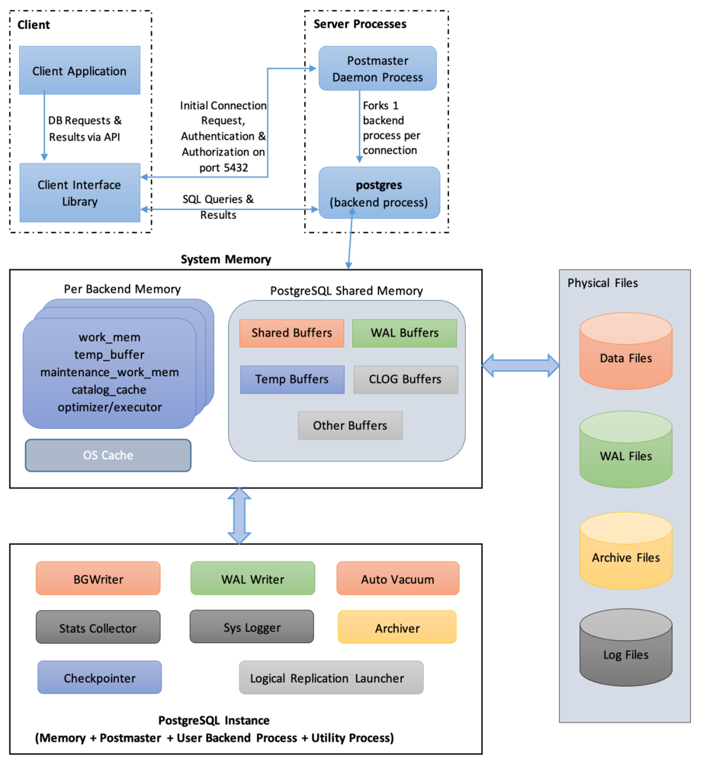
Stores application & business data.
Service | Purpose
MySQL / MariaDB | Relational databases
PostgreSQL | Advanced relational DB
MongoDB | NoSQL document DB
Redis | Cache / session store
Elasticsearch | Search & analytics
InfluxDB | Time-series data

5️⃣ File, Storage & Sharing Services

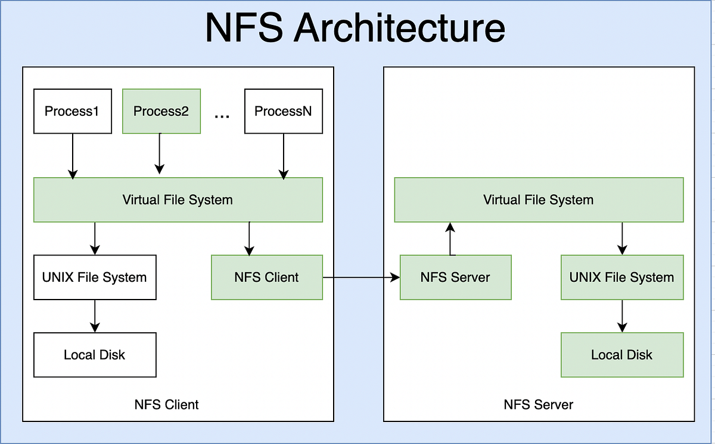
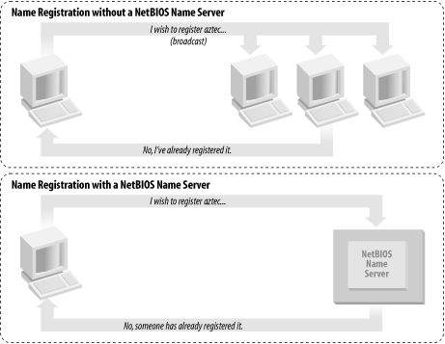
Used for shared storage and backups.
Service | Purpose
Samba (SMB/CIFS) | Windows file sharing
NFS | Unix/Linux file sharing
FTP / SFTP | File transfers
rsync | Efficient backups
iSCSI target | Block-level storage
Ceph / GlusterFS | Distributed storage

6️⃣ Security & Identity Services
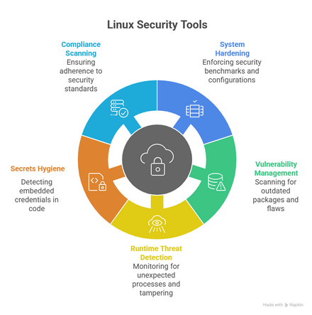

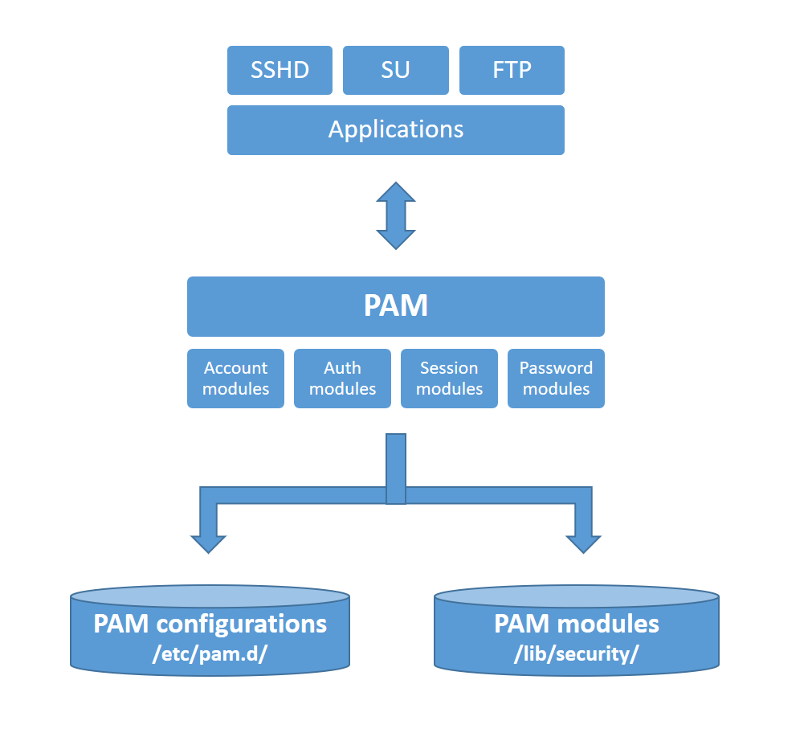
Controls who can access what.
Service | Purpose
PAM | Authentication framework
LDAP | Centralized user directory
Kerberos | Strong authentication
SELinux / AppArmor | Mandatory access control
ClamAV | Antivirus (limited but used in mail/file servers)
Auditd | Security auditing

7️⃣ Email & Messaging Services

For mail servers and notifications.
Service | Purpose
Postfix / Sendmail | Mail transfer
Dovecot | Mail access (IMAP/POP3)
SpamAssassin | Spam filtering
OpenDKIM | Email authentication

8️⃣ Monitoring, Logging & Operations
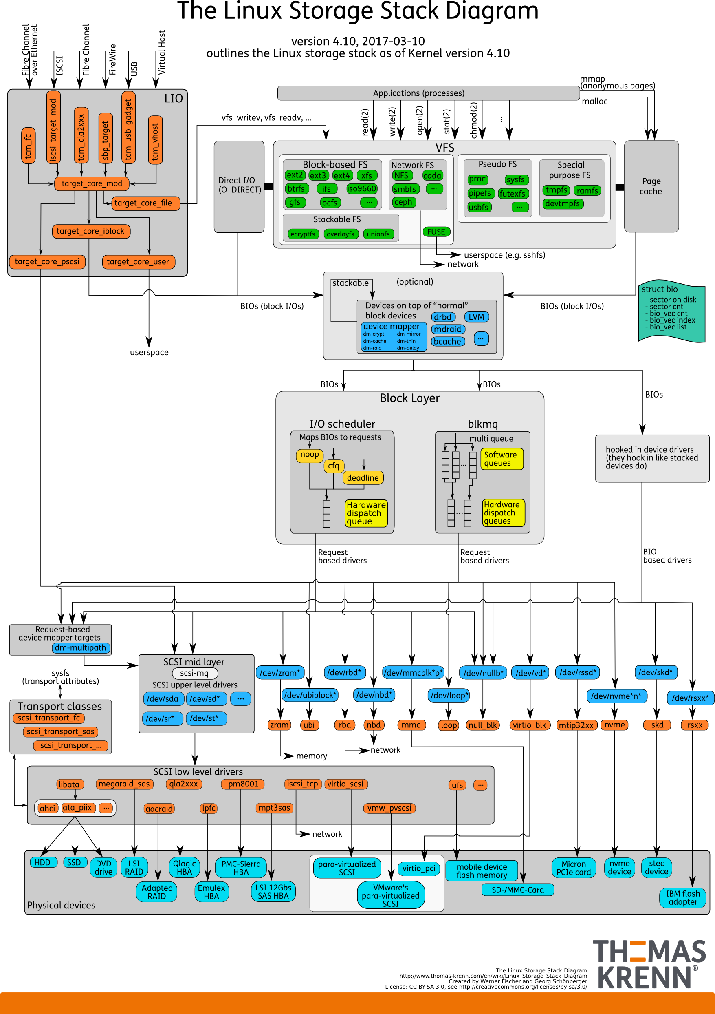
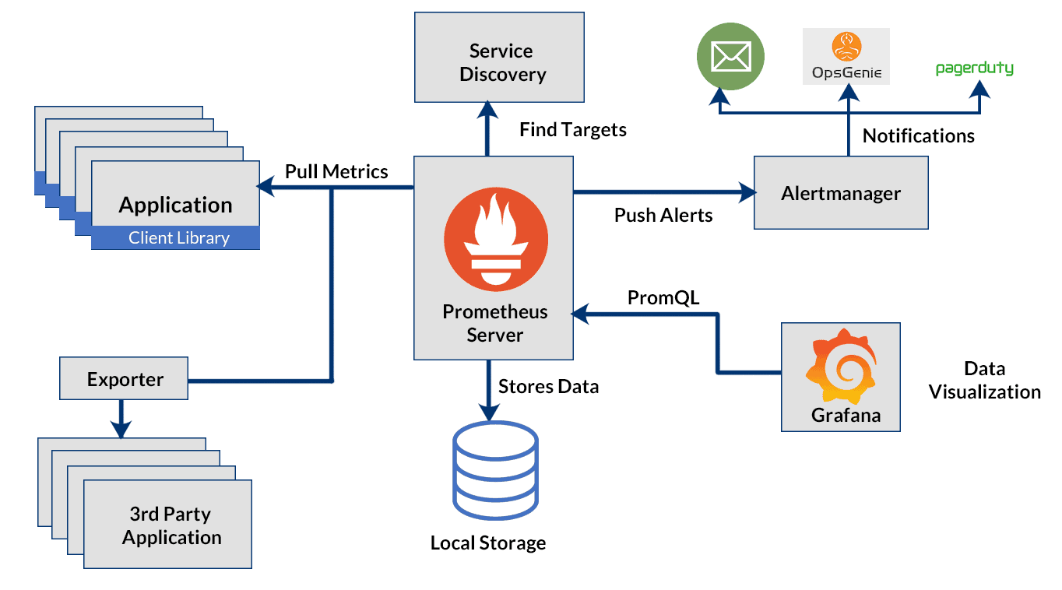
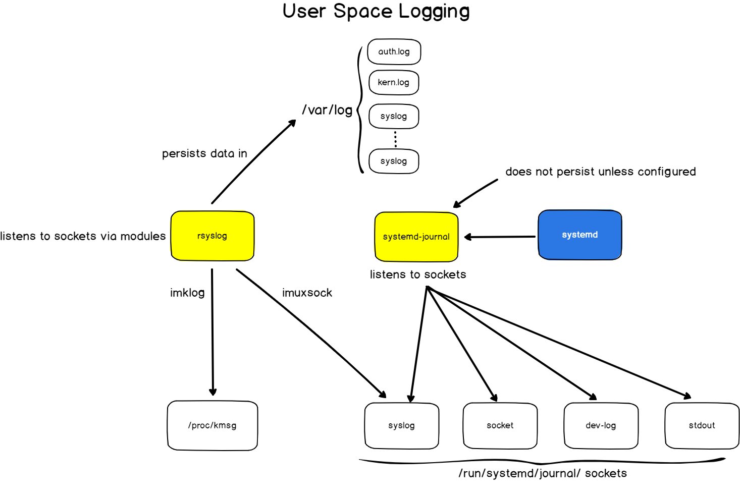
Keeps the server healthy & observable.
Service | Purpose
top / htop | Resource monitoring
Nagios / Zabbix | Infrastructure monitoring
Prometheus + Grafana | Metrics & dashboards
ELK Stack | Centralized logging
Netdata | Real-time monitoring

9️⃣ Container & Virtualization Services (Modern Servers)

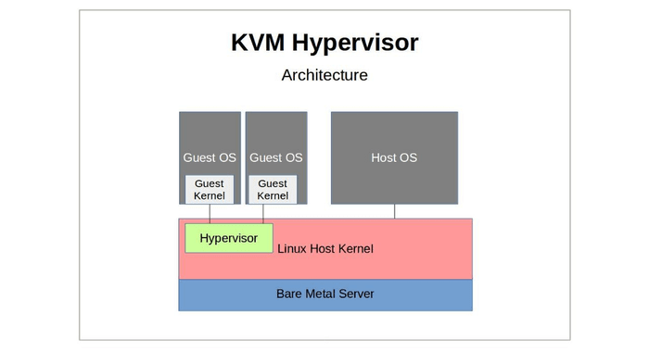
Used in cloud & DevOps environments.
Service | Purpose
Docker | Container runtime
containerd / Podman | Secure container engines
Kubernetes (k8s) | Container orchestration
KVM / QEMU | Virtual machines
Libvirt | VM management

Map these services to AWS / Azure / GCP equivalents
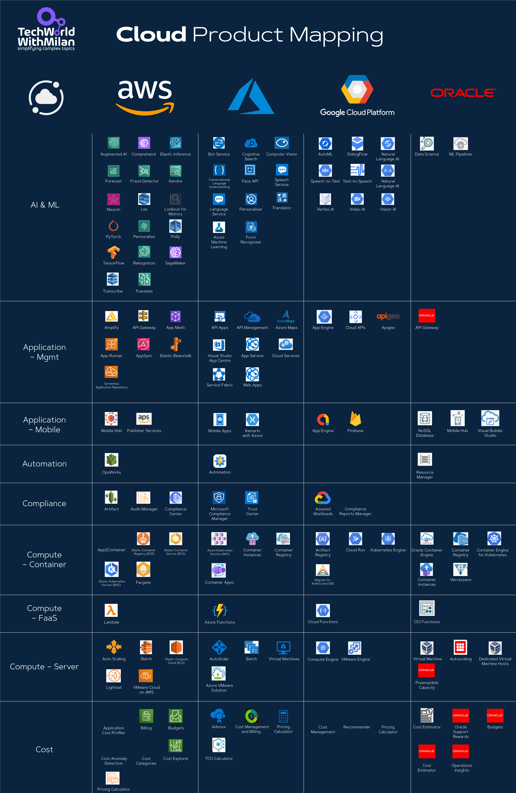
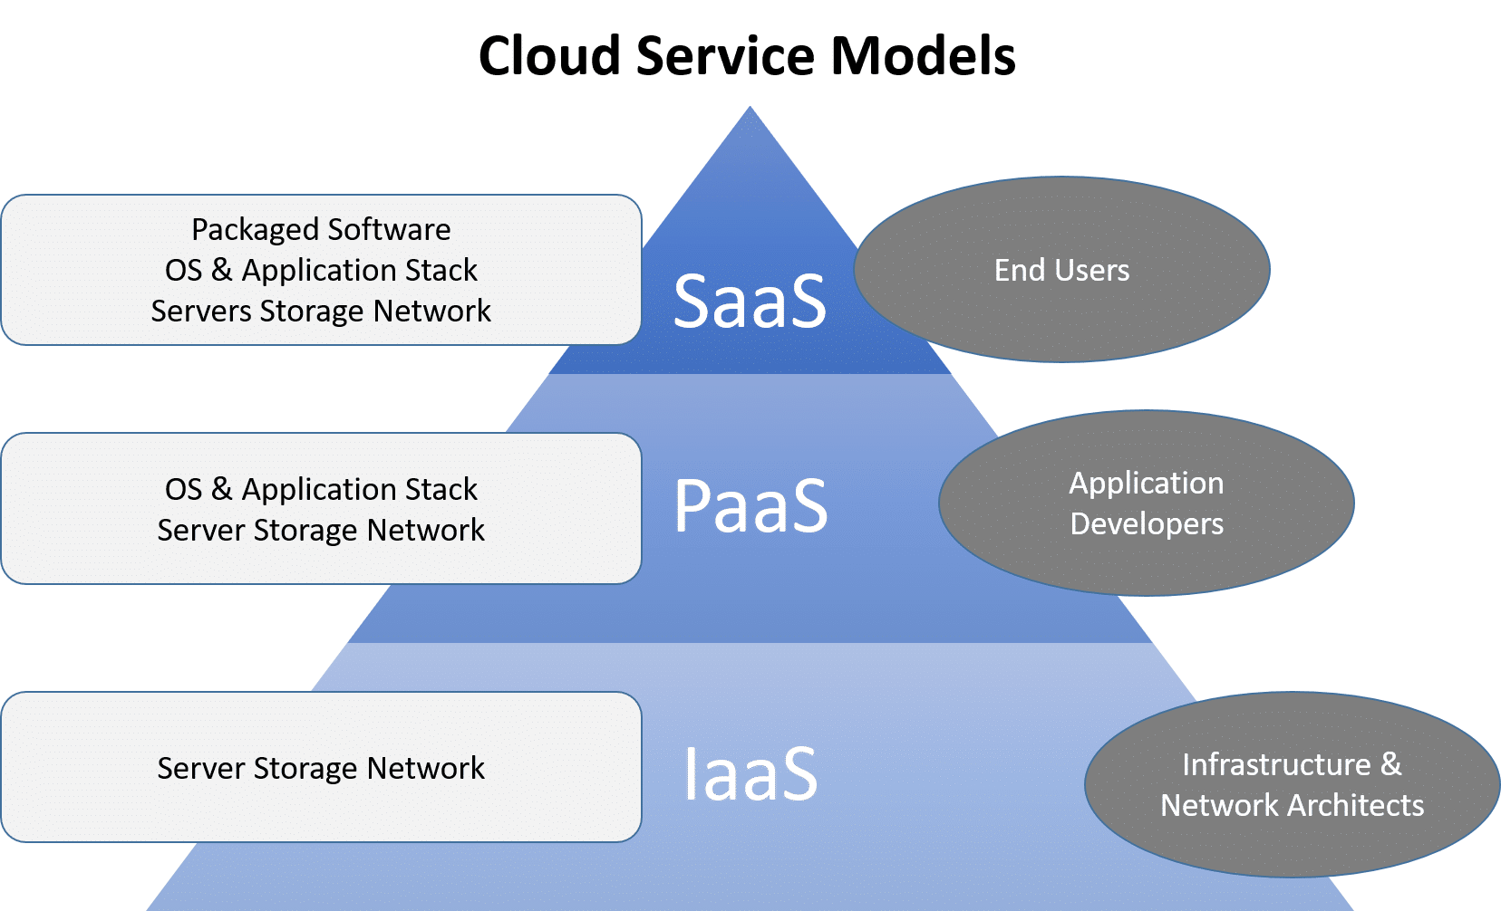
Below is a clean, teaching-ready mapping of typical Linux server services → AWS / Azure / GCP managed equivalents.
This is exactly how on-prem Linux admin thinking translates into cloud architecture.

One-Look Mental Mapping
On-Prem Thinking | Cloud Thinking
Configure OS | Define policy
Secure the host | Secure identity
Patch servers | Use managed services
Monitor logs | Centralized observability
Scale vertically | Scale horizontally

1️⃣ Core System & Access Services
Linux Service | AWS Equivalent | Azure Equivalent | GCP Equivalent
SSH (sshd) | EC2 key pairs / SSM Session Manager | Azure VM SSH / Bastion | Compute Engine SSH
sudo, local users | IAM Roles / IAM Users | Entra ID (Azure AD) RBAC | Cloud IAM
systemd | EC2 / AMI lifecycle | VM Scale Sets | Instance Templates
cron / at | EventBridge + Lambda | Logic Apps / Automation Accounts | Cloud Scheduler
rsyslog / journald | CloudWatch Logs | Azure Monitor / Log Analytics | Cloud Logging
NTP / chrony | Amazon Time Sync | Azure Time Sync | Google Time Sync
fail2ban | AWS WAF / Shield | Azure DDoS Protection | Cloud Armor
📌 Cloud principle: OS-level controls → identity & policy-driven controls

2️⃣ Networking & Name Resolution
Linux Service | AWS | Azure | GCP
Network config | VPC | Virtual Network (VNet) | VPC
DNS client/server | Route 53 | Azure DNS | Cloud DNS
DHCP | VPC DHCP | Azure DHCP | VPC DHCP
Firewall (iptables/nft) | Security Groups / NACL | NSG / Azure Firewall | VPC Firewall Rules
Reverse proxy | ALB / NLB | Application Gateway | Cloud Load Balancer
Proxy (Squid) | NAT Gateway | NAT Gateway | Cloud NAT

3️⃣ Web & Application Services
Linux Stack | AWS | Azure | GCP
Apache / Nginx | EC2 + ALB | VM + App Gateway | Compute Engine + LB
PHP-FPM | Elastic Beanstalk | App Service | App Engine
Java (Tomcat) | Elastic Beanstalk | App Service (Java) | App Engine
Node.js | Lambda / App Runner | Azure Functions | Cloud Functions
Python (Flask/Django) | Lambda / ECS | Azure Functions | Cloud Functions
📌 Cloud shift: Server-based → PaaS / FaaS

4️⃣ Database & Data Services
Linux DB | AWS | Azure | GCP
MySQL / MariaDB | RDS | Azure Database for MySQL | Cloud SQL
PostgreSQL | RDS | Azure Database for PostgreSQL | Cloud SQL
MongoDB | Amazon DocumentDB | Cosmos DB (Mongo API) | Mongo Atlas
Redis | ElastiCache | Azure Cache for Redis | Memorystore
Elasticsearch | OpenSearch | Azure AI Search | Elastic Cloud
InfluxDB | Timestream | Azure Data Explorer | Bigtable

5️⃣ File, Storage & Backup
Linux Service | AWS | Azure | GCP
Samba (SMB) | FSx | Azure Files | Filestore
NFS | EFS | Azure NetApp Files | Filestore
rsync backups | S3 | Blob Storage | Cloud Storage
iSCSI | EBS | Managed Disks | Persistent Disks
Object storage | S3 | Blob Storage | Cloud Storage
Archive | Glacier | Blob Archive | Coldline / Archive

6️⃣ Security & Identity
Linux Security | AWS | Azure | GCP
PAM / local auth | IAM | Entra ID | Cloud IAM
LDAP | Directory Service | Entra ID DS | Managed AD
Kerberos | Managed AD | Entra ID | Managed AD
SELinux/AppArmor | IAM + SCP | Azure Policy | Org Policy
Auditd | CloudTrail | Azure Activity Logs | Cloud Audit Logs
Antivirus | GuardDuty | Defender for Cloud | Security Command Center
📌 Key shift: Host-based security → identity + policy + telemetry

7️⃣ Email & Messaging
Linux Mail | AWS | Azure | GCP
Postfix | SES | Exchange Online | Gmail
Dovecot | WorkMail | Exchange Online | Gmail
SpamAssassin | SES Filters | Defender for O365 | Gmail AI Spam
DKIM | SES DKIM | DKIM in O365 | DKIM in Workspace

8️⃣ Monitoring, Logging & Ops
Linux Tool | AWS | Azure | GCP
top / htop | CloudWatch Metrics | Azure Monitor | Cloud Monitoring
Nagios/Zabbix | CloudWatch + SNS | Azure Monitor Alerts | Alerting
ELK Stack | OpenSearch | Log Analytics | Cloud Logging
Grafana | Managed Grafana | Azure Managed Grafana | Managed Grafana

9️⃣ Containers & Virtualization
Linux | AWS | Azure | GCP
Docker | ECS / ECR | ACR / Container Apps | Artifact Registry
Kubernetes | EKS | AKS | GKE
KVM/QEMU | EC2 | Azure VMs | Compute Engine
Libvirt | AWS Console | Azure Portal | GCP Console

